[1]

Low-cost datalogger intended for remote monitoring of solar photovoltaic stand-alone systems based on ArduinoTM

Ascensión López-Vargas, Manuel Fuentes, Marta Vivar and Francisco J. Muñoz-Rodríguez

*Abstract*— A low-cost datalogger intended for stand-alone photovoltaic (PV) systems in developing countries was designed employing open source software and hardware. The low-cost datalogger is capable of measuring electrical and meteorological parameters meeting the accuracy requirements established by the International Electro-technical Commission (IEC) standard for PV monitoring systems. The new datalogger allows the installation of the monitoring system in areas deprived of telecommunications networks, storing data in SD card and requiring minimal maintenance. A real stand-alone PV (SAPV) system similar to those employed in developing countries was installed at IMDEA Water Institute facilities (Madrid, Spain) for testing and validating the new low-cost datalogger under real conditions. The results demonstrated compliance with the IEC standard, monitoring all of the requested parameters with high accuracy and low power consumption.

*Index Terms*— Data acquisition system, stand-alone PV systems, low-cost sensors, monitoring, IEC standard.

# INTRODUCTION

I

N recent years, the fast evolution of renewable energies and, particularly, solar PV technology, has led to a proliferation of PV installations throughout the world. PV systems can be categorized into two types: grid-connected PV systems and stand-alone PV systems. Grid-connected PV systems usually have high budgets, and the associated data acquisition devices, commonly known as dataloggers, allow to measure the main parameters to carry out the necessary corrective and maintenance actions without a high impact on the total installation cost. However, in the case of stand-alone PV systems, the installations are limited by size and cost factors. Most of these systems are located in remote locations, commonly in developing countries: large programmes have installed thousands of SAPV systems in rural areas of Asia, Africa, and Latin America. Unfortunately, it is very difficult to track the functioning of this type of systems mainly because the required dataloggers are too expensive in comparison with the total system cost, demand special software and usually require a power supply or a PC to be connected all of the time. But it is necessary to monitor SAPV systems accurately and at low cost because the impossibility of detecting operation and maintenance problems, can lead to a dramatic shortening of the useful life of the PV systems. The cost of commercial dataloggers has decreased in recent years, although it is still too high, in some cases even surpassing the price of the complete stand-alone PV system. As a result, further development of data acquisition systems is required to monitor SAPV systems under operation, under the premise of obtaining the measured parameters using accurate, autonomous and low-cost systems.

Analytical monitoring has been gradually applied to small PV installations because the prices for data acquisition hardware have decreased more rapidly than the prices of PV systems; the monitoring of SAPV systems is of special interest for both solar energy research and applications in developing countries The literature includes various reports of PV data acquisition systems during the last several years. One of the first low-cost systems designed for solar radiation monitoring was developed by R.Mukaro et al. [1] in 1998. The monitoring system was based on an 8-bit microcontroller. With 4 analogue inputs, an analogue-digital converter (ADC) was used and data was stored until uploaded to a portable computer. Sampling interval was 10 minutes and low-power mode was implemented between intervals minimizing power consumption. This system was suitable for monitoring of meteorological parameters at remote stations, especially in developing countries, but the need to connect this system to a computer proofed to be a disadvantage. Another integrated data acquisition system for renewable energy sources was reported by E. Koutroulis and K. Kalaitzakis [2] in 2003. The datalogger uses a data acquisition card installed in a PC with 16 single ended or eight differential analog, an ADC converter with a 12-bit accuracy, 8 digital input/output channels and 2 up/down timer/counters. However, the use of commercial software and the dependence on a PC, increased the price of the system. A dedicated data acquisition system for remote monitoring the operation of a stand-alone PV appliance was developed by G. M. Tina and A. D. Grasso [3] in 2014. The system adopted low-cost commercial sensors and components to measure electrical and environmental parameters. The data acquisition board comprised 20 analog inputs. The information provided by the data acquisition board was acquired by a web-based application. However, measurements were not compared with another calibrated data acquisition system and the error of measurements was not bounded. F. Touati et al. [4] in 2016 proposed a cost-effective PV monitoring system with ubiquitous access and processing of data through a local wireless system. The hardware components consisted of a microcontroller, 6 sensors with signal conditioning circuits, a DC-DC buck-boost converter and XBee modules. The main disadvantage of this system was the requirement of a Labview™ based monitoring and recording station. Other designs found in the literature depend on a PC [5-8], commercial software [9] or do not follow international standards of accuracy [10, 11].

M. Fuentes et al. [12] in 2014 developed a low-cost prototype based on open source and open source hardware technologies for monitoring PV systems, especially in remote areas or regions in developing countries. The datalogger accomplished the accuracy requirements of the IEC standards for PV systems. The datalogger resolution was 18-bits, including 8 analogue inputs for measuring up to 8 PV modules parameters or weather sensors, 3 inputs for low-cost analogue temperature sensors and virtually unlimited inputs for digital temperature sensors. The datalogger was tested during summer and winter in Southern Spain. The datalogger monitored a stand-alone PV system and a micro-grid-connected PV system. The results indicated that the data acquisition system was reliable and exhibited comparable performance to commercial systems. However, the datalogger presented various shortcomings: (a) it would need to minimize power consumptions, (b) it presented a low input voltage range and (c) it did not have a user-friendly interface.

The ultimate goal of this work has been to develop an improved and extended version of this low-cost datalogger in order to overcome the shortcomings mentioned above. The new prototype has been specifically designed for stand-alone PV systems located in remote areas. Main new datalogger characteristics are: (a) low-cost, employing open source software and hardware, (b) autonomous operation, independently of a computer, (c) high accuracy, meeting the IEC standard requirements, (d) robustness in outdoor, (e) low power consumption, using software and hardware techniques, (f) flexibility to be adapted to different stand-alone PV systems, (g) user-friendly interface and (h) data storage , allowing the installation of the system in areas deprived of telecommunications networks, requiring minimal maintenance.

# SAPV systems in developing countries

As this work aims to develop a datalogger intended for SAPV systems in developing countries, the main characteristics of this type of applications have been reviewed including the typical daily energy consumption, the corresponding load profile and the most common characteristics of the SAPV systems used in developing countries.

For this review, studies focusing on rural electrification in developing countries [13-16] and renewable-based initiatives energy programs [17] have been used.

## Typical stand-alone PV system in rural applications in developing countries

Large programmes have installed thousands of SHS (Solar Home Systems) in rural areas of Asia, Africa, and Latin America. For this review, the most significant programmes (grouped by continent) are:

a) In Asia, more than 6 million SHS are in operation, of which 3 million are installed in Bangladesh [17]. These systems are usually composed by a solar module of 10-350Wp, a 12V 15-130Ah deep cycle tubular battery and a charge controller, as given by Grameen Shakti Corporation [18]. On the other hand, thousands [19] of SHS have been installed in India under the National Solar Mission [20], and one of the main goals is to promote programmes for off grid applications. The capacities covered under the Indian programme are from 10W to 200W. However, three configurations have been commonly used in India as reported by ThriveTM Solar Energy Private Limited Corporation [21]: 110Wp solar modules and 12V 75Ah batteries, 250Wp solar modules and 12V 100Ah batteries, and 300Wp solar modules and 12V 120Ah batteries.

b) In Africa, an estimated 300,000 rural households in Kenya have SHS according to Kenya Renewable Energy Association [22]. In general, systems are composed by a module of 20-120Wp, a battery of 12V 30-100Ah and a charge controller. In Tanzania, SHS constitute around 75% of the installed solar PV capacity as indicated by U. E. Hansen et al. in 2014 [23]. These systems include a solar module of 80-200Wp, a battery and a charge controller.

c) Going to Latin America, the SHS program in Peru uses a crystalline module of 60-80Wp, a 12V 100Ah gel sealed lead-acid battery and a 10A charge controller. 3,000 SHS have been installed in Peru and 2,400 systems operate using 80Wp according to Acciona Microenergía Corporation [24].

Coming to the main components of an SHS, in general, all these initiatives use crystalline-silicon PV modules. Regarding the other key component of a SAPV system, the battery, in the SHS initiatives reviewed, lead-acid has been the type of battery technology widely used. The performance reliability of a SAPV system is determined by the long-term performance of its battery. Finally, SHS programmes have included a charge controller. Charge controllers present special features in order to enhance the battery lifetime (boost charging and pulsed charging) and to improve charging efficiency. The most common approaches for charge controllers are the shunt, series, pulse width modulation (PWM) and Maximum Power Point Tracking (MPPT) charge controllers [25]. Most small SHS employ charge controllers using PWM to regulate the charge current to the battery as reported by N.J. Williams et al. [26] in 2011. The charge controller makes up only a small fraction (5% approximately) of the complete cost of a SHS [27].

## Daily energy consumption and typical load profile in rural applications in developing countries

To estimate the daily energy consumption in a household, it is required to identify all the appliances in terms of power (W) and their daily usage in terms of hours per day. For example, T. Kulworawanichpong and J.J. Mwambeleko in 2015 [13] estimated the average daily energy consumption of a typical rural household in Tanzania, showing the power consumption per appliance / lighting. The lighting load of these typical rural households consisted of 12 VDC LED lamps, with an average daily usage of 4 hours. Regarding daily usage profile, A. El Fathi et al. in 2014 [14] measured typical load curves of 16 households located in the remote rural village of Elkaria (province of Essaouira in Morocco) and they showed that most of the consumption occurs after 6:00 PM (lights and TVs are on) although some smaller peaks are observed around 8:00 AM and around noon.

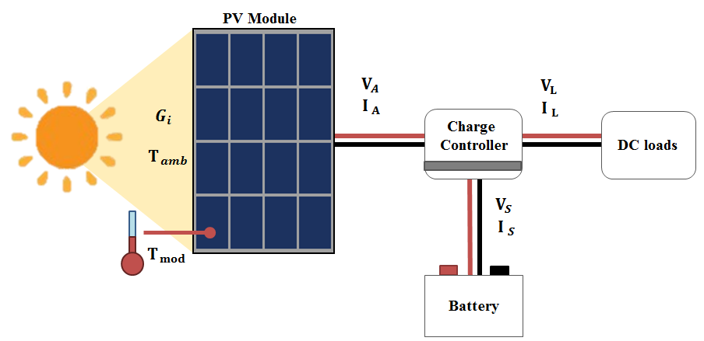

Fig. 1. Diagram of the parameters measured in real time for SAPV systems.

In another study, D.O.Akinyele and R.K.Rayudu in 2016 [15] showed the maximum load demand of 24 houses located in a remote community in Abuja, Nigeria. Most of the consumption occurred around 8:00 PM (lights and TVs are on) and smaller peaks were observed around 7:00 AM and 4:00 PM.

In general, a typical home in a developing country will have several lamps for lighting and it might have a TV, fans, phone charger or a small refrigerator. Typical configurations have been widely identified in the literature (Table I).

TABLE II

Parameters to be monitored in real time PV systems

|  |  |  |
| --- | --- | --- |
| General parameters | Specific parameters | Symbol |
| Meteorology | Total irradiance, in the plane of the array | Gi |
|  | Ambient temperature in a radiation shield | Tamb |
|  | Wind speed (optional) | - |
|  | Rainfall (optional) | - |
|  | Humidity (optional) | - |
| PVarray | Output voltage | VA |
|  | Output current | IA |
|  | Output power | PA |
|  | PV module temperature | Tmod |
| Energy storage | Operating voltage | VS |
|  | Current to storagea | ITS |
|  | Current from storagea | IFS |
|  | Power to storagea | PTS |
|  | Power from storagea | PFS |
| Load | Load voltage | VL |
|  | Load current | IL |
|  | Load power | PL |
| Utility grid | Utility voltage | VU |
|  | Current to utility grida | ITU |
|  | Current from utility grida | IFU |
|  | Power to utility grida | PTU |
|  | Power from utility grida | PFU |
| Back-up sources | Output voltage | VBU |
|  | Output current | IBU |
|  | Output power | PBU |

aA single current or power sensor can be used for the measurement of current or power for directions or both input and output.

TABLE I

Power generation of the system and typical load configuration used in SHS programmes

|  |  |  |
| --- | --- | --- |
| Country | PV power generation range | Load system |
| Bangladesh | 10-350Wp | Basic LED tube lighting, fans and LCD/LED TVs [18] |
| India | 10-200Wp | Compact fluorescent lamps, fans and TV [20] |
| Kenya | 20-120Wp | Lights and TV/radio [28] |
| Tanzania | 80-200Wp | LED lights, radios, mobile phones, TVs [23] |
| Peru | 60-80Wp | Energy efficient lamps, cell phone charger, TV/radio [24] |

# Requirements for the SAPV system monitoring

International standards set the parameters that must be measured and monitored in photovoltaic systems [29, 30]. The IEC61724 standard [29] titled “Photovoltaic system performance” describes the general guidelines for the monitoring and analysis of the electrical performance of photovoltaic systems (stand-alone and grid connected). In Table II a summary of such parameters is presented.

Photovoltaic (PV) has become a practical technology for remote areas, especially stand-alone PV systems because of electric grid connection is not required. For characterizing SAPV systems, the measurement of electrical properties and atmospheric conditions is essential. An example of the IEC61724 standard appliance for SAPV systems is shown in Fig. 1.

## Electrical parameters

The number of parameters to be measured (Table II) determines the number of inputs and therefore it is an important starting point of the datalogger design. In the specific case of electrical measurements, if the current sensor can distinguish the direction of the current, the number of parameters to be monitored can be reduced.

According to IEC61724 standard, the accuracy of the voltage, current and power measurements, including signal conditioning, must be better than 2% of the reading (high accuracy class).

## Meteorological data

With the aim to satisfy the IEC61724 standard, climatic parameters must be measured at a location that is representative of the SAPV system conditions and all of them, optional and mandatory parameters (Table II), must comply the standard requirements of accuracy. The accuracy of PV module temperature measurements must be better than ±2 ºC, the accuracy of ambient temperature measures must be better than ±1 ºC of and the accuracy of irradiance measures must be better than 8% of the reading from 100 W∙m-2 to 1,500 W∙m-2 (including signal conditioning). The measurement of optional parameters such as wind speed, also must comply the standard requirements of accuracy: ≤ 0. 5 m⋅s-1 for wind speeds ≤ 5 m⋅s-1, and ≤ 10 % of the reading for wind speeds greater than 5 m⋅s-1.

## Data storage

Data storage is an important process for carrying out any monitoring or performance analysis. The SAPV system was specifically designed for being installed in developing countries and sending data may not always be possible due to the lack of coverage in rural areas [31]. Hence, the method of data storage selected should ensure to keep collected data and to work autonomously, requiring minimal maintenance. According to IEC61724, it is necessary to keep all of the data collected in files organised by dates.

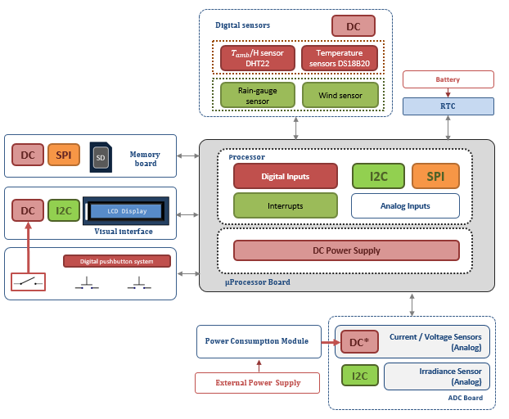

Fig. 2. Diagram of the new prototype including improved modules (analog and digital sensors modules, ADC board) and new modules (visual interface, digital pushbutton system and power consumption module).

# Design of the new datalogger

In this section, the new low-cost datalogger is presented, including both hardware and software. The microprocessor manages all the modules using appropriate communications protocols that will be detailed next. Fig.2 shows a general view of the design of the new datalogger, including current and voltage sensors, ADC board, Real-Time Clock (RTC), digital sensors, memory board, visual interface, digital pushbutton system and power consumption module.

## Selection of microprocessor

The selection of the appropriate hardware was based on the use of open-sorce software and hardware that allows to achieve the low-cost objective of the final system. Within the numerous platforms based on open-source hardware available in the market, ArduinoTM UNO stands out in comparison with the others due to its flexibility, cost and developer community [12]. The hardware is based on the ATmega328 microcontroller and it has 14 digital input/output pins, 6 analogue inputs, a power jack and a USB connection. The board contains everything required to support the microcontroller and it can operate using an external supply.

This microcontroller is comparable in price to the lowest cost options, but its flexibility to adapt any design poses an additional advantage over the other low cost platforms. The software can be downloaded for free and the hardware reference designs are available under an open-source license, and the users are free to adapt them to their needs. Another key advantage of ArduinoTM is its developer community. A worldwide community of developers has gathered around this open-source platform and support is available in numerous webpages, being examples and libraries. Regarding the operating temperature, the ATmega328P microcontroller operates effectively within the range of temperature from -40 ºC to 125ºC.

On the other hand, one of the main weaknesses of ArduinoTM UNO is the internal memory limitation. ArduinoTM UNO has 32K bytes of Flash Memory (program space) and 2K bytes of SRAM (Static Random Access Memory) [32]. Due to these memory limitations, the optimization of the program is an essential task. Another disadvantage of ArduinoTM UNO is the resolution. The board has 6 analogue inputs with an ADC of 10-bit resolution. This resolution is not sufficient for meeting all of the requirements of the IEC61724 standard because there are some sensors, such as the irradiance sensors for example, that have amplitudes in the range of hundreds of microvolts and need at least 16-bit resolution or amplifier systems to improve the measurement range.

## Hardware improvement

Due to the basic ArduinoTM UNO hardware limitations explained previously that hinders the possibility of meeting the IEC61724 standard requirements, hardware enhancements were required. To overcome the main limitations, all the new hardware designs were integrated in an ad-hoc PCB (Printed Circuit Board). The main hardware improvements were:

1. An I2C™ bus was integrated in the PCB using the pins A5 and A4 of ArduinoTM UNO. An I2C™ connector and an additional reset button were also included.
2. A RTC for tracking time and ensuring the precise synchronization of the measurements was included. The selected external clock was the DS1307 serial RTC from Maxim IntegratedTM. DS1307 uses the I2C™ bus and operates under its particular battery independently of the board power supply.
3. Two external ADCs MCP3424 of 18-bits resolution from Microchip™ were also integrated to overcome the resolution limitation of ArduinoTM UNO to accomplish the IEC61724 accuracy requirements. These ADCs have four differential channels with an input range of ±2.048V for monitoring up to 8 analogue inputs with high accuracy. PGA (Programmable-Gain Amplifier) gain of x1, x2, x4, or x8, before the analog-to-digital conversion takes place, can be selected by the user via software. The error introduced in this process is negligible compared to the error introduced by the sensors. MCP3424 uses the I2CTM bus. Regarding operating temperatures, these ADCs can work in the temperature range -40°C to +125°C.
4. A SD flash memory was employed to overcome the memory limitations of the ArduinoTM UNO board. This data storage method is characterized by its high storage density, rapid speeds of reading and writing, and its low price. Due to the small size of the daily data files (plain text archives, written in single-byte ASCII code), using a 4GB SD card, there is available space for up to 10 years of measurements. The communication with the SD card was bas ed on SPI (Serial Peripheral Interface) [33].
5. A visual interface based on a display and a pushbutton system was added to communicate with the system. An LCD (Liquid Crystal Display) module was employed as a user interface. The connection of this shield requires only two digital pins since it uses the I2C™ bus to communicate with the ArduinoTM board. The backlight can be set via software. At each iteration, the 16 x 2 LCD screen switches on showing the information measured by sensors.
6. A power consumption module was implemented with a bipolar transistor to power active sensors only in the timeframe necessary. In this way, the power consumption will be minimized. As results, voltage and current sensors only were enabled 3.4 seconds per cycle of 30 seconds of duration, with a power reduction of 88.6 % (of the total sensors consumption).

## Selection of meteorological sensors

The first prototype of the new portable datalogger [12] covered the measurement of only irradiance and ambient temperature parameters. Employing exclusively low-cost sensors, the new extended and specific version for stand-alone PV systems includes a wide range of climatic measurements: irradiance, ambient temperature, humidity, wind velocity and rainfall.

### *Irradiance*

The IEC standards IEC60904-2 [34] and IEC60904-6 [35] give the requirements for photovoltaic reference systems. It covers a variety of devices used as reference sensors, such as single photovoltaic cells or small modules. With the aim of reducing costs, calibrated PV cells were used to measure the solar irradiance, concretely 2.2W mono-crystalline cells from Nousol [12].

### *Ambient temperature and humidity*

The DHT22 sensor from Aosong was selected for measuring both relative humidity and ambient temperature. This sensor provides a precision of ±0.5℃, measuring ambient temperature in the range of -40℃ to +80℃. Additionally, the DHT22 sensor allows to measure the relative humidity in the range of 0%RH to 100%RH, measuring the relative humidity with a precision of ±3%RH.

### *Wind*

An anemometer sensor from Thies Clima was used to acquire the horizontal wind velocity. The microcontroller was configured to count clicks (as external interrupts) which are caused due to anemometer magnetic reed switch pulses, so the number of pulses is proportional to the wind speed. This sensor operates in the range of 0.9 m/s to 40 m/s with an accuracy of ± 0.5 m/s.

### *Precipitation*

The rain gauge sensor measures the amount of rainfall in a given surface within a specific time interval. The Rain-O-Matic Small sensor from PronamicTM was selected. This sensor measures the rainfall by means of a funnel which leads the water down into the self-emptying tipping bucket, held in place by a hard ferrite magnet [36]. The output of this sensor was also declared as a microcontroller interrupt by software. The number of clicks within a specific time interval (30 seconds in this case) is the proportional to precipitation. The sensor interrupts the microcontroller each time the click occurs and the number of clicks is registered.

## Selection of SAPV system parameter sensors

This section presents the improvements on sensing methods with respect to the first prototype of the low-cost datalogger [12]. The SAPV system parameters measured and recorded by the monitoring system include voltages, currents and temperatures that have been empirically validated in alignment with the IEC61724 standard accuracy requirements.

### *Temperatures*

DS18B20 temperature sensors from Maxim IntegratedTM [37] were used to acquire PV module and PV battery temperatures. DS18B20 sensors use the 1-Wire bus: a communications protocol that has a single bus master and one or more slaves.

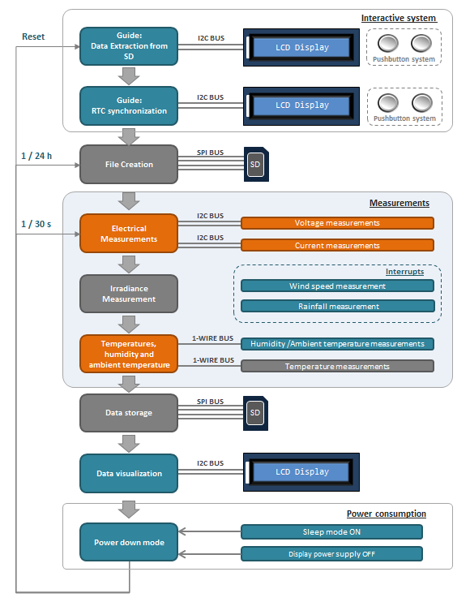

Fig.3: Diagram for the routine executed by each iteration: sequence of processes and communications. New processes (blue) and improved processes (orange) over the first prototype of the low-cost datalogger [2] are shown.

DS18B20 sensors have a 9 to 12 bit selectable resolution. In accordance with IEC61724 standard, the accuracy of these temperature sensors must be better than ±2ºC, so the highest resolution was selected. The operating temperature range of these sensors is -55°C to 125°C, but the manufacturer ensures a ±0.5°C accuracy from the operating temperature range of -10°C to +85°C. To avoid moisture and water-related problems, the waterproof version of the sensor was selected.

### *Electrical parameters: Voltage measurement*

The voltage parameters measured and recorded by the new low-cost monitoring system include the PV generator output voltage (VA), battery voltage (VS) and load voltage (VL). For this purpose, individual low-cost voltage sensors were developed.

Voltage dividers that increase the ADC input range from ±2.048V were used. Additionally, three common-mode voltage amplifiers were also used to allow measuring differential signals in presence of high common-mode voltage range accurately. The output of these dividers provided voltage level to measurable range without risk of damage. PV generator output voltage (VA) sensor was scaled down by VOUT/VIN=1/76. Battery output voltage (VS) and load voltage (VL) sensors dividers were based on VOUT/VIN=1/51 proportion.

### Electrical parameters: Current measurement

The current parameters measured and recorded by the new datalogger include PV generator output current (IA), battery current (IS) and load current (IL). Three types of current sensors based on two different technologies: precision resistors (shunts) and Hall effect, were developed and tested in order to select the most adequate one for the SAPV system monitoring.Current sensors were empirically validated by comparing the results obtained with a high precision datalogger (22-bit resolution). After a full campaign of experiments, the best results in terms of accuracy were offered by the LTS sensors. The main advantage of these Hall effect sensors over resistive shunts was a minimum power loss. A further advantage of employing this technique is that these Hall Effect sensors are fully non-invasive current sensors.

## Software

TABLE III

Daily energy consumption estimation of a typical household in developing countries

|  |  |  |  |  |  |
| --- | --- | --- | --- | --- | --- |
|  | No. Of lamps | Watt per lamp | Watt-lamp | Hours per day | Energy per day [Wh] |
| Bedroom1 | 2 | 3 | 6 | 2 | 12 |
| Bedroom2 | 2 | 3 | 6 | 2 | 12 |
| Kitchen | 2 | 5 | 10 | 1.5 | 15 |
| Living room | 2 | 5 | 10 | 4 | 40 |
| **Total** |  |  |  |  | **79** |
|  |  |  |  |  |  |

The algorithm has been coded in the ArduinoTM [32] C/C++ subset language, its own open source programing language, using the ArduinoTM IDE. As the IEC61724 standard [1] advises sampling intervals below 1min for parameters related to irradiance, 30s has been the interval chosen, and data are recorded. Every day a new file is created, and these files are recorded and organized by date in the SD memory.

Fig. 3 shows the flow diagram of the process followed by the microprocessor. Every minute, at second 0 and second 30, parameters are measured. First, the most variable parameters are measured, and later, parameters with low instantaneous fluctuations. Thus, electrical parameters are measured and later, meteorological parameters. A green LED switches on for a few seconds in a cyclical way every time the parameters are measured, indicating that the software runs correctly. In addition, after measuring, data is stored in the SD card and the results are shown on the LCD screen.

Software improvements have been developed and new processes have been included:

1. An interactive system based on the display and a pushbutton system allows the user to control internal processes. After initializing, the display provides information about the SD data extraction. A message is displayed advising the user that data can be extracted from the SD of safely. The monitoring system stays in standby mode until the user extracts data from the SD card and the pushbutton is pressed (specified by the display). If after 10 minutes the button is not pressed, the next code is executed, preventing failures in the case of an unexpected restart (e.g. because of a power failure event).
2. A synchronization option has been included to account for potential drifts of the RTC during the operation of the system (usually a few seconds per week): the display shows detailed steps about the synchronization process, and time (hour, minute and second) can be selected by the user.

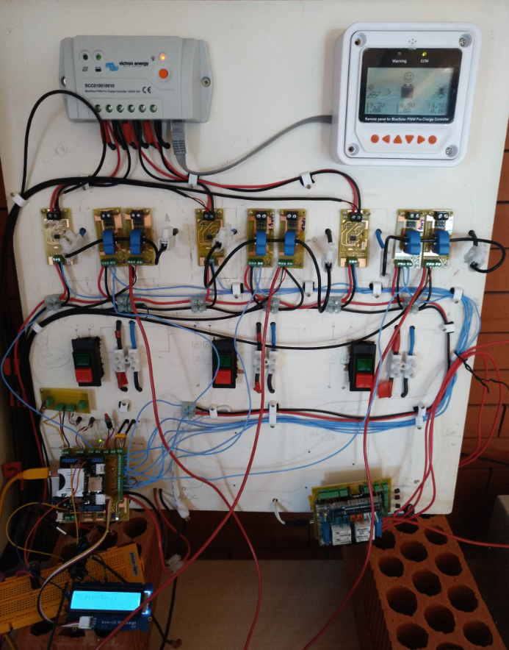

Fig. 5. Final prototype assembly. The charge regulator uses a control panel for displaying real-time information on the SAPV system. The datalogger shows the information on a LCD display. The datalogger uses 9 small PCBs for electrical sensing (current and voltage measurements). The load control system includes an ArduinoTM UNO board and a relay system.

1. New climatic measurements have been included: horizontal wind speed and rainfall measurements have been implemented as external interrupts, and the measurement of relative humidity.

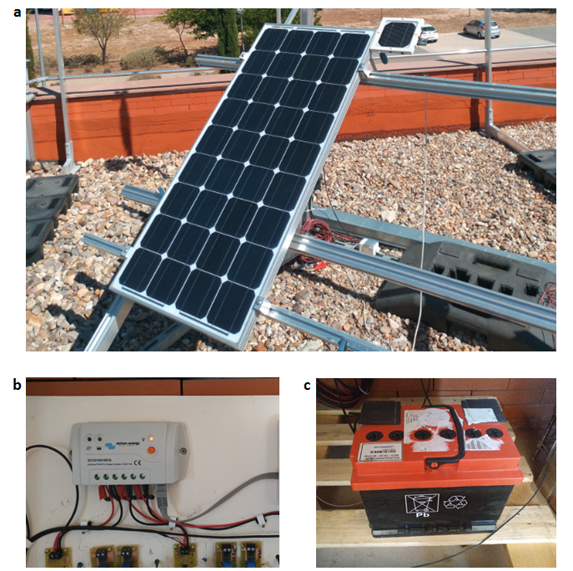

Fig. 4. SAPV system installation: PV mono-crystalline module (a), charge controller (b) and lead-acid battery (c).

1. The process of measuring voltage and current parameters has been improved. The order of magnitude of voltage measurements is greater than the order of magnitude of current measurements. The PGA gain of each one of the ADCs has been configured via software in order to increase the resolution of the current measurements, optimizing the ADCs performance and reducing errors.

Several software strategies have been followed to reduce the power consumption:

1. In order to minimize power consumption via software, the decreasing of clock speed [32] was employed. Clock frequency was set to 1MHz during inactive periods of the microcontroller and default clock frequency, 8MHz, was maintained in the process of measurements. The application of this technique resulted in a power consumption reduction of 10mA (microcontroller), a reduction of 13.85%.
2. Sleep modes [38] were also employed for reducing power consumption: these techniques put the device in a low power state disabling functions in periods of inactivity. The sleep mode was implemented using libraries that disabled the onboard ADC of the ArduinoTM UNO and Brown-Out Detection (BOD) by software, saving 23mA of the power consumption (microcontroller), a reduction of 35.38%.

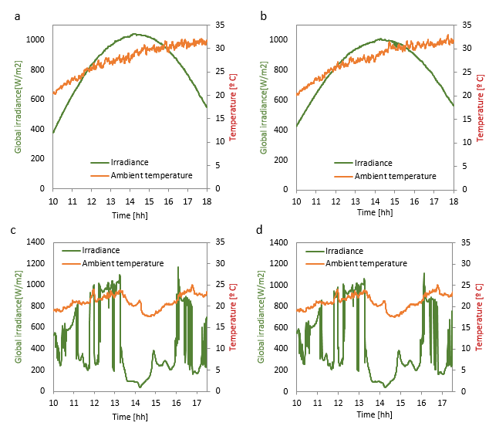

Fig. 6: Comparison between the irradiance and ambient temperature measured by the ArduinoTM datalogger (a) and by the AgilentTM datalogger (b) on 7/6/2017 (clear sky conditions, sunny day). Comparison between the irradiance together with the ambient temperature using the low-cost datalogger (c) and the AgilentTM datalogger (d) on 8/7/2017 (cloudy day).

1. Individual techniques based on the management of the LCD power supply were developed. After showing the information, the display was disabled until next cycle for reducing power consumption. A pushbutton connected to D5 pin allowed to switch on /off the display by the user.

# Experimental validation

To verify the correct performance of the new low-cost datalogger under real conditions, a real stand-alone PV system similar to those typically employed in developing countries was installed at the test facilities in IMDEA Water Institute (Madrid, Spain, latitude 40.51° N, longitude 3.34° W).

## Experimental set-up

Studies on rural electrification in developing countries and renewable-based initiatives energy programs (see Section 2) were reviewed to design the real SAPV system. The final installed stand-alone PV system (Fig.4) included an 80W mono-crystalline module, a 12-V lead-acid battery (90Ah-C100) and a PWM serial charge controller.

Typical domestic energy consumption of a household in developing countries will usually have several lamps for lighting and it might also have a small household appliance (see literature review details in Section 2). All the commonly used appliances in terms of power and hours of usage per day were identified for estimating the daily energy consumption used in this work (Table III, from literature review).

The daily energy distribution in terms of hours per day provided information to estimate the load profile. The load system was composed by two 12-V luminaries of 3W and 50W, respectively. A load management system based on ArduinoTM UNO was developed to automate the switching of the lights. An RTC DS1307 was integrated for carrying out the tracking of the time and a relay system composed by four relays allowed the load control.

Fig. 5 shows the final prototype of the new low-cost datalogger including current and voltage sensors.

## Results

An experimental campaign at IMDEA Water Institute was performed to verify the correct performance of the new low-cost datalogger. The parameters measured by the new low-cost dataloger were compared with a commercial monitoring system that acted as a pattern. This pattern commercial monitoring system is an AgilentTM 34972 datalogger of 22 bits with a voltage accuracy resolution of 0.004% that uses LabviewTM. Every 30 s, this datalogger measured and recorded the same parameters as the ArduinoTM datalogger.

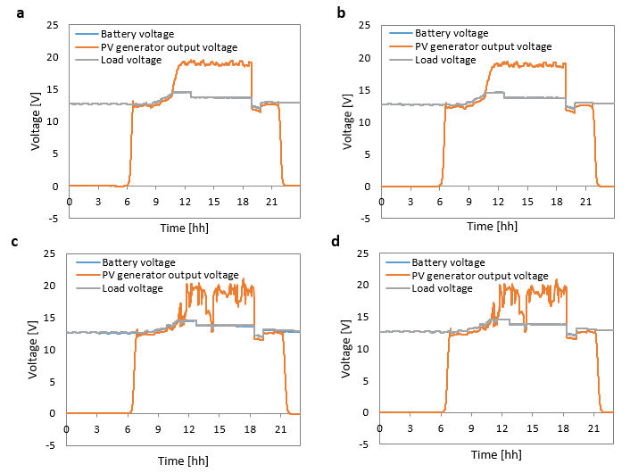

Fig. 7: Comparison between the voltages measured by the low-cost datalogger (a) and the AgilentTM datalogger (b) on 7/6/2017 (clear sky conditions, sunny day). Comparison between the voltages measured by the ArduinoTM datalogger (c) and the AgilentTM datalogger (d) on 8/7/2017 (cloudy day).

### Meteorological data monitoring

Climatic parameters measured by the low-cost datalogger were compared to another commercial weather station located at IMDEA Water Institute facilities (Madrid, Spain). The AgilentTM datalogger measured the global solar irradiance using a pyranometer CMP21, Kipp and ZonenTM and the ambient temperature using a PT100 with shield protector. Fig. 6 shows the daily profile of the irradiance and the ambient temperature monitored by the low-cost ArduinoTM datalogger and the commercial AgilentTM datalogger. On the left we can observe the results for the low–cost monitoring system and on the right for the AgilentTM datalogger. The irradiance and the ambient temperature measured by the ArduinoTM datalogger using low-cost sensors under clear sky conditions (Fig.13a) reveal a good fitting of these parameters with the measurements of the AgilentTM datalogger (Fig. 13b). The ArduinoTM datalogger works well under adverse climatic conditions (Fig. 13c) regarding the measurements of the AgilentTM datalogger (Fig. 13d).

Table IV shows the statistical parameters of the root mean square error (RMSE) and the mean bias error (MBE) [12]. Irradiance and ambient temperature measured by the new low-cost datalogger and the commercial datalogger are also compared in cloudy and sunny conditions. The uncertainly of irradiance measures was below the 8% required by the standard. According to IEC standard, the accuracy of ambient temperature measures must be better than ±1 ºC: the mean absolute errors [39] of measured ambient temperatures were 0.02 ºC (clear sky conditions) and 0.015 ºC (cloudy day).

TABLE IV

Results of the comparison between irradiance and ambient temperature measured by the low-cost datalogger and the commercial datalogger under different climatic conditions

|  |  |  |  |  |
| --- | --- | --- | --- | --- |
|  | Sunny day | | Cloudy day | |
|  | RMSE (%) | MBE (%) | RMSE (%) | MBE (%) |
| Irradiance | 3.038 | 1.608 | 4.288 | -0.422 |
| Ambient temperature | 1.241 | -0.440 | 2.978 | -0.334 |

### SAPV system parameters monitoring

The electrical data were processed to analyse the performance of the SAPV system. Due to the use of a PWM charge controller, it was convenient to operate with charge parameters instead of energy parameters [40].

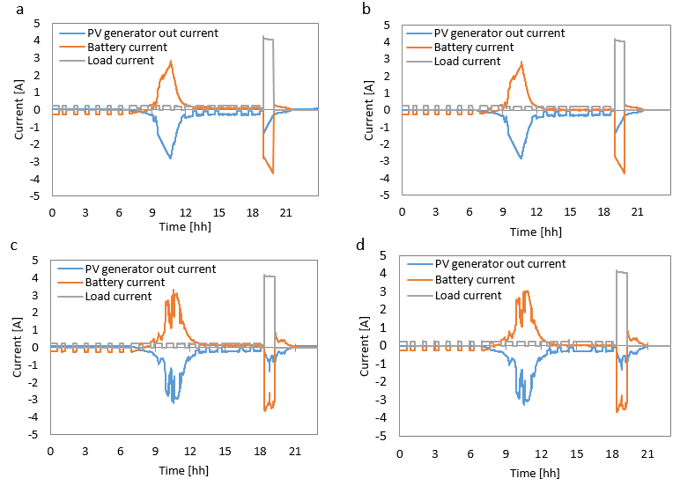

Fig. 8: Comparison between the currents measured by the low-cost datalogger (a) and the AgilentTM datalogger (b) on 7/6/2017 (sunny day). Comparison between the currents measured by the low-cost datalogger (c) and the AgilentTM datalogger (d) on 8/7/2017 (cloudy day).

Fig. 7 shows the voltages monitored by the low-cost datalogger and the AgilentTM datalogger. It shows the measurements of the PV generator output voltage, the battery voltage and the load voltage. Battery voltage line and load voltage line overlap. Both the voltages measured by the ArduinoTM datalogger using low-cost sensors under c lear sky conditions (Fig.7a) and under adverse climatic conditions (Fig. 7c) exhibit a good fit regarding these voltage parameters with the AgilentTM datalogger measurements (Fig. 7b and Fig. 7d respectively), demonstrating the correct functioning of the ArduinoTM datalogger under different climatic conditions.

TABLE V

Results of the comparison between the electrical parameters measured by the low-cost datalogger and the commercial datalogger. The uncertainly was below the 2% required by the standard

|  |  |  |  |
| --- | --- | --- | --- |
|  | NRMSE (%) in a sunny day | NMRSE (%) in a cloudy day | |
| PV generator output voltage | 0.139 | | 0.889 |
| Battery voltage | 0.033 | | 0.639 |
| Load voltage | 0.049 | | 0.083 |
| PV generator out current | 0.161 | | 0.566 |
| Battery current | 0.299 | | 0.805 |
| Load current | 0.038 | | 0.758 |

TABLE VI

Results of the comparison between the electrical parameters measured by the low-cost datalogger and the commercial datalogger. The uncertainly was below the 2% required by the standard.

|  |  |  |  |  |
| --- | --- | --- | --- | --- |
|  | Sunny day | | Cloudy day | |
|  | RMSE (%) | MBE (%) | RMSE (%) | MBE (%) |
| Battery temperature | 0.642 | 0.435 | 2.808 | -0.038 |
| PV module temperature | 3.323 | -0.266 | 3.498 | -0.479 |

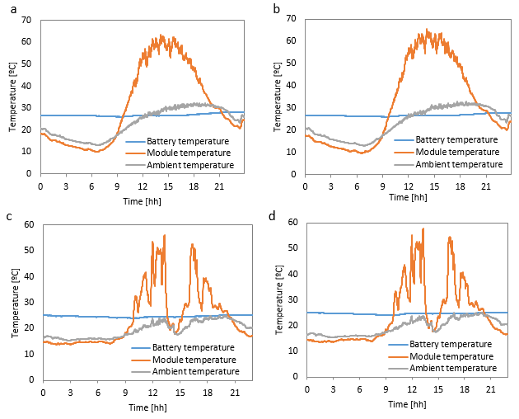

Fig. 9: Comparison between temperatures (Tmod, Tbat, Tamb) measured by the low-cost datalogger (a) and the pattern commercial system (b) on 7/6/2017.This day was a sunny day. Comparison between temperatures (Tmod, Tbat, Tamb) measured by the low-cost datalogger (c) and the pattern commercial system (d) on 8/7/2017.This day was a cloudy day.

Fig.8 shows the measurements of the PV generator out current, the battery current and the load current. Negative values of currents mean the supply of power. Positive values mean the consumption of power. The data taken by the ArduinoTM datalogger under clear sky conditions (Fig. 8a) show the good fitting of the current parameters with the measurements of the AgilentTM datalogger (Fig. 8b). The data taken by the ArduinoTM datalogger (Fig. 8c) also reveal a good fit regarding these current parameters with the AgilentTM datalogger measurements (Fig.8d) under adverse climatic conditions.

Table V shows the statistical parameters of the normalized root mean squared error (NMRSE), which provide a global error measure during the entire forecasting period [39] for electrical measurements.

The battery temperature, the module temperature and the ambient temperature monitored by the low-cost datalogger (a, c) and the AgilentTM datalogger (b, d) are shown in Fig. 9. Back module temperature and battery temperature were measured by the AgilentTM datalogger using flat PT100 sensors located at their back part. Temperatures measured by the ArduinoTM datalogger using low-cost sensors under clear sky conditions (Fig.9a) and under adverse climatic conditions (Fig. 9c) show a good fit regarding these temperature parameters with the AgilentTM datalogger measurements (Fig. 9b and Fig.9d respectively). It demonstrates the correct functioning of the ArduinoTM datalogger under different climatic conditions.

TABLE VIII

Budget for low cost sensors and low-cost weather station components

|  |  |  |
| --- | --- | --- |
| Components | | Price[€] |
| 3 Digital temperature sensors DS18B20 | 10.50 | |
| Irradiance sensor | 39.90 | |
| Rain gauge sensor | 35.20 | |
| Anemometer | 120.00 | |
| Temperature and humidity sensor DHT22 | 2.69 | |
| Solar radiation shield for temperature sensor | 59.88 | |
| **TOTAL** | **268.17** | |

TABLE VII

Budget for the new low-cost datalogger .

|  |  |  |  |
| --- | --- | --- | --- |
|  | Components | Price[€] | |
| ArduinoTM UNO | Stocked board | | 17.95 |
| Memory board | Stocked board | | 1.55 |
|  | SD memory card | | 3.96 |
| Visualization module | LCD 16x2 | | 3.46 |
| ADC Board | 2 MCP3424 | | 6.84 |
|  | RTC DS1307 | | 1.58 |
|  | Precision resistors, Capacitors | | 1.80 |
|  | Wires, connectors | | 0.70 |
| Pushbutton System | Switch | | 0.32 |
|  | 2 Pushbuttons | | 0.40 |
| Power consumption | NPN transistor | | 0.29 |
| Adaptor for high current sensing | 3 LTS-15NP LEM | | 18.86 |
|  | 9 Resistors SMD | | 5.40 |
|  | 3 Voltage reference | | 2.79 |
| Adaptor for high voltage sensing | 3 Differential Amplifiers | | 11.31 |
|  | 6 Resistors SMD | | 3.60 |
|  | **TOTAL** | | **80.81** |

Table VI shows the statistical parameters of the root mean square error (RMSE) and the mean bias error (MBE) [12]. PV module temperature and battery temperature measured by the low-cost datalogger and the commercial datalogger are compared. According to IEC standard, the accuracy of PV module temperature measures must be better than ±2 ºC: the mean absolute errors of measured PV module temperatures were 0.781 ºC (clear sky conditions) and 0.295 ºC (cloudy day). The mean absolute errors of measured battery temperatures were 0.225 ºC (sunny day) and 0.016 ºC (cloudy day).

# Costs

The aim of this work was to develop a new prototype of a datalogger that is low-cost, accurate and autonomous. The budget of the monitoring system is described in Table VII. The final cost of the new prototype, including high voltage and current sensing, was approximately 81€. Table VIII shows the budget for the low cost sensors. The budget of low-cost sensors (including the low-cost weather station) was approximately 268€. Total costs could be reduced considerably when mass produced and introduced in the market.

# Conclusions

A new low-cost datalogger logger intended for stand-alone PV systems in developing countries meeting the accuracy requirements established by the IEC61724 standard related to photovoltaic monitoring system was presented. A real stand-alone PV system including the corresponding load system and the most common characteristics of the SAPV system used in developing countries was installed for testing and validating the new low-cost datalogger under real conditions.

The new prototype of the low-cost datalogger improved the measurement of climatic conditions and the measurement of SAPV system parameters employing exclusively low-cost sensors. The monitoring system included a wide range of climatic measures: irradiance, temperatures, humidity, horizontal wind speed and rainfall. Voltage and current parameters were monitored using improved amplifiers, voltage dividers, and Hall-effect sensors to adapt the measurement to the designed monitoring system. The SD data storageallowed to keep collected data and to work autonomously in areas deprived of telecommunications networks, requiring minimal maintenance. In addition, measures were shown on a LCD screen and an interactive system based on a display and a pushbutton system allowed the user to control internal processes such as data extraction from SD card and RTC synchronization. Total power consumption of the datalogging system was minimized by applying specific techniques to reduce both sensors and microprocessor board power consumptions.

An outdoor campaign of over one month at IMDEA Water Institute, in Alcalá de Henares (Madrid, Spain), was performed to test the new low-cost datalogger. The comparison of the results with those of other monitoring systems demonstrated compliance with the IEC61724 standard, monitoring all of the requested parameters with high accuracy.

In addition, after demonstrating the good accuracy of the low-cost datalogger and sensors, a network using an expanded version of the presented monitoring system (wireless) was installed under outdoor conditions demonstraing the robutness and fiability [41].

Acknowledgment

A. López-Vargas acknowledges funding from the Spanish Ministry of Economy and Competitiveness, ‘Ayudas para la Promoción de Empleo Joven e Implantación de la Garantía Juvenil en I+D+i’ Programme, Grant number PEJ-2014-A-42354.

M. Vivar acknowledges funding from the Spanish Ministry of Economy and Competitiveness, ‘Ramon y Cajal’ Programme, Grant number RYC-2015-17306.

References

1. R. Mukaro, X. Carelse, and L. Olumekor, First performance analysis of a silicon-cell microcontroller-based solar radiation monitoring system, Sol. Energy, vol. 63, no. 5, pp. 313–321, Nov. 1998.
2. E. Koutroulis and K. Kalaitzakis, Development of an integrated data-acquisition system for renewable energy sources systems monitoring, Renew. Energy, vol. 28, no. 1, pp. 139–152, 2003.
3. G. M. Tina and A. D. Grasso, Remote monitoring system for stand-alone photovoltaic power plants: The case study of a PV-powered outdoor refrigerator, Energy Convers. Manag., vol. 78, pp. 862–871, 2014.
4. F. Touati, M. A. Al-Hitmi, N. A. Chowdhury, J. A. Hamad, and A. J. R. San Pedro Gonzales, Investigation of solar PV performance under Doha weather using a customized measurement and monitoring system, Renew. Energy, vol. 89, pp. 564–577, 2016.
5. M. Benghanem, Low cost management for photovoltaic systems in isolated site with new IV characterization model proposed, Energy Convers. Manag., vol. 50, no. 3, pp. 748–755, Mar. 2009.
6. M. Demirtas, I. Sefa, E. Irmak, and I. Colak, Low-cost and high sensitive microcontroller based data acquisition system for renewable energy sources, 2008 Int. Symp. Power Electron. Electr. Drives, Autom. Motion, pp. 196–199, 2008.
7. M. Benghanem and A. Maafi, Performance of stand-alone photovoltaic systems using measured meteorological data for Algiers, Renew. Energy, vol. 13, no. 4, pp. 495–504, Apr. 1998.
8. M. Benghanem, A. H. Arab, and K. Mukadam, Data acquisition system for photovoltaic water pumps, Renew. Energy, vol. 17, no. 3, pp. 385–396, Jul. 1999.
9. M. Benghanem, Measurement of meteorological data based on wireless data acquisition system monitoring, Appl. Energy, vol. 86, no. 12, pp. 2651–2660, Dec. 2009.
10. A. Purwadi, Y. Haroen, F. Y. Ali, N. Heryana, D. Nurafiat, and A. Assegaf, Prototype development of a Low Cost data logger for PV based LED Street Lighting System, Proc. 2011 Int. Conf. Electr. Eng. Informatics, no. July, pp. 1–5, 2011.
11. M. Ikhsan, A. Purwadi, N. Hariyanto, N. Heryana, and Y. Haroen, Study of Renewable Energy Sources Capacity and Loading Using Data Logger for Sizing of Solar-wind Hybrid Power System, Procedia Technol., vol. 11, no. Iceei, pp. 1048–1053, 2013.
12. M. Fuentes, M. Vivar, J. M. Burgos, J. Aguilera, and J. A. Vacas, Design of an accurate, low-cost autonomous datalogger for PV system monitoring using ArduinoTM that complies with IEC standards, Sol. Energy Mater. Sol. Cells, vol. 130, pp. 529–543, Nov. 2014.
13. T. Kulworawanichpong and J. J. Mwambeleko, Design and costing of a stand-alone solar photovoltaic system for a Tanzanian rural household, Sustain. Energy Technol. Assessments, vol. 12, pp. 53–59, 2015.
14. A. El Fathi, L. Nkhaili, A. Bennouna, and A. Outzourhit, Performance parameters of a standalone PV plant, Energy Convers. Manag., vol. 86, pp. 490–495, 2014.
15. D. O. Akinyele and R. K. Rayudu, Strategy for developing energy systems for remote communities: Insights to best practices and sustainability, Sustain. Energy Technol. Assessments, vol. 16, pp. 106–127, 2016.
16. G. D. Kamalapur and R. Y. Udaykumar, Rural electrification in India and feasibility of Photovoltaic Solar Home Systems, Int. J. Electr. Power Energy Syst., vol. 33, no. 3, pp. 594–599, 2011.
17. R. Kempener, O. Lavagne, D. Saygin, J. Skeer, S. Vinci, and D. Gielen, Off-Grid Renewable Energy Systems: Status and Methodological Issues, International Renewable Energy Agency, 2015.
18. < http://www.gshakti.org > (accessed 30.12.18).
19. < http://anert.gov.in/index.php?option=com_content&view=article&id=9&Itemid=4> (accessed 28.12.18).
20. < http://mnre.gov.in > (accessed 28.12.18).
21. <http://www.thriveenergy.co.in/subsidy-schemes/mnre-nabard-solar-home-lighting> (accessed 30.12.18).
22. < http://kerea.org > (accessed 30.12.18).
23. U.E. Hansen, M.B. Pedersen and I. Nygaard, Review of Solar PV Market Development in East Africa, UNEP Risø Centre UNEP Risø Cent. Work. Pap. Ser., no. 12, 2014.
24. Luz en casa – Case study, Fundación ACCIONA ,2014 < http://www.accioname.org/ > (accessed 30.12.18).
25. Y. E. Abu, N. H. Saad, and A. Zekry, Enhancing the design of battery charging controllers for photovoltaic systems, Renew. Sustain. Energy Rev., vol. 58, pp. 646–655, 2016.
26. N.J. Williams, E. Ernest van Dyk, F.J. Vorster, Monitoring solar home systems with pulse width modulation charge control. J Sol Energy Eng 2011;133:021006- 1–021006-7.
27. F. D. J. Nieuwenhout, A. Van Dijk, P. E. Lasschuit, G. Van Roekel, V. A. P. Van Dijk, D. Hirsch, H. Arriaza, M. Hankins, B. D. Sharma, and H. Wade, Experience with solar home systems in developing countries: A review, Prog. Photovoltaics Res. Appl., vol. 9, no. 6, pp. 455–474, 2001.
28. < http://sollatek.co.ke/shop/solar-lighting/solarhomekit/ > (accessed 30.12.18).
29. IEC61724-1. Photovoltaic System Performance- Part 1: Monitoring. 1st Ed., International Electrotechnical Commission (IEC), Switzerland, Geneva, 2017.
30. Commission of the European Communities. Photovoltaic System Monitoring, Documents A & B, version 4.3 ed., Guidelines for the Assessment of Photovoltaic Plants; 1997.
31. ICT facts and Figures 2016, International Telecommunication Union <https://www.itu.int/en/ITU-D/Statistics/Documents/facts/ICTFactsFigures2016.pdf > (accessed 30.12.18).
32. < https://www.arduino.cc > (accessed 30.12.18).
33. K. M. Lynch, N. Marchuk, and M. L. Elwin, SPI Communication, Embed. Comput. Mechatronics with PIC32, pp. 177–190, 2016.
34. IEC, Photovoltaic Devices: Requirements for Reference Solar Devices, 2nd Ed., International Electrotechnical Commission (IEC), Switzerland, Geneva, 2007 (60904-2).
35. IEC, Photovoltaic Devices. Requirements for Reference Solar Modules, 1st Ed., International Electrotechnical Commission (IEC), Switzerland, Geneva (1994) 60904–60906.
36. < http://pronamic.com/products/rain-o-matic-small > (accessed 30.12.18).
37. < https://www.maximintegrated.com > (accessed 21.06.17).
38. S. Monk, Programming Arduino Getting Start With Sketches, McGraw-Hill, 2011.
39. J. Zhang, A. Florita, B. Hodge, S. Lu, H. F. Hamann, V. Banunarayanan, and A. M. Brockway, A suite of metrics for assessing the performance of solar power forecasting ,Sol. Energy, vol. 111, pp. 157–175, 2015.
40. F.J.Muñoz, G. Almonacid, G. Nofuentes, and F. Almonacid, A new method based on charge parameters to analyse the performance of stand-alone photovoltaic systems, Sol. Energy Mater. Sol. Cells, vol. 90, pp. 1750–1763, 2006.
41. A. López-Vargas, M. Fuentes and M. Vivar, "IoT Application for Real-Time Monitoring of Solar Home Systems Based on Arduino™ With 3G Connectivity," in IEEE Sensors Journal, vol. 19, no. 2, pp. 679-691, 15 Jan.15, 2019.

1. Manuscript received December 5, 2018.

   A. López-Vargas is with the Water & Energy Group, IMDEA Water Institute, Alcalá de Henares 28805, Spain. (e-mail: asuvargas@gmail.com).

   M. Fuentes is with the Grupo IDEA, University of Jaén, Jaén 23071, Spain. M. Fuentes is with the Water & Energy Group, IMDEA Water Institute, Alcalá de Henares 28805, Spain . (e-mail: mfuentes@ujaen.es).

   M. Vivar is with the Grupo IDEA, University of Jaén, Jaén 23071, Spain. (e-mail: marta.vivar@gmail.com). Francisco J. Muñoz-Rodríguez is with the Grupo IDEA, University of Jaén, Jaén 23071, Spain.